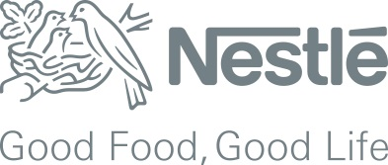

If you want to apply for this position, please submit to HR Dept your Resume prior to this below email

**30th April 2017**.

Further information, please feel free to contact:

[Tranthikim.nga@vn.nestle.com](mailto:Tranthikim.nga@vn.nestle.com) Tel : 0618 877 999 Ext : 5107 (Ms. Nga)

Please note that unqualified candidates will not be selected to interview.

*Thank you for your attention. Recruitment – Human Resources Department*

*.*

**Job Requirements:**

* Education requirement: Bachelor’s degree in Mechanic/ Mechatronics and other related majors.
* Above 3 year related experience in manufacturing company
* Good English
* Logical thinking, eager to learn, people development, dare to challenge
* Leadership potential

**Job Description:**

**Operation Management of production lines:**

* Ensure Health & Safety conditions for a Safe Working Environment
* Ensure that finished products are consistently manufactured according to standards of quality, on time, and meeting consumer expectations
* Manage Production effectively through operational reviews and use Standard Routines to ensure sustainable results and drive continuous improvement to deliver breakthrough results.
* Ensure the timely launch of new or renovated products to the Markets as per agreement with the business.
* Develop and deploy the Capability Development for own team to ensure the team member are fulfilled required skills, and also develop team members for back up positions to ensure running production lines smoothly.
* Lead the peers to deploy the action plan or requirement from Pillar or other committees.
* Plan for peers closing skill gaps of which are defined according to TPM phases.
* To grant co-operation to concerned Department for trials: new product development, line modification.
* Other tasks assigned by line manager

RECRUITMENT ANNOUNCEMENT

**Production Supervisor**

**Working place:** Dong Nai Factory

**Report to:** Production Manager